Website proposal for Tailoring and shoe repair.

**Lebohang R.ST10487152**

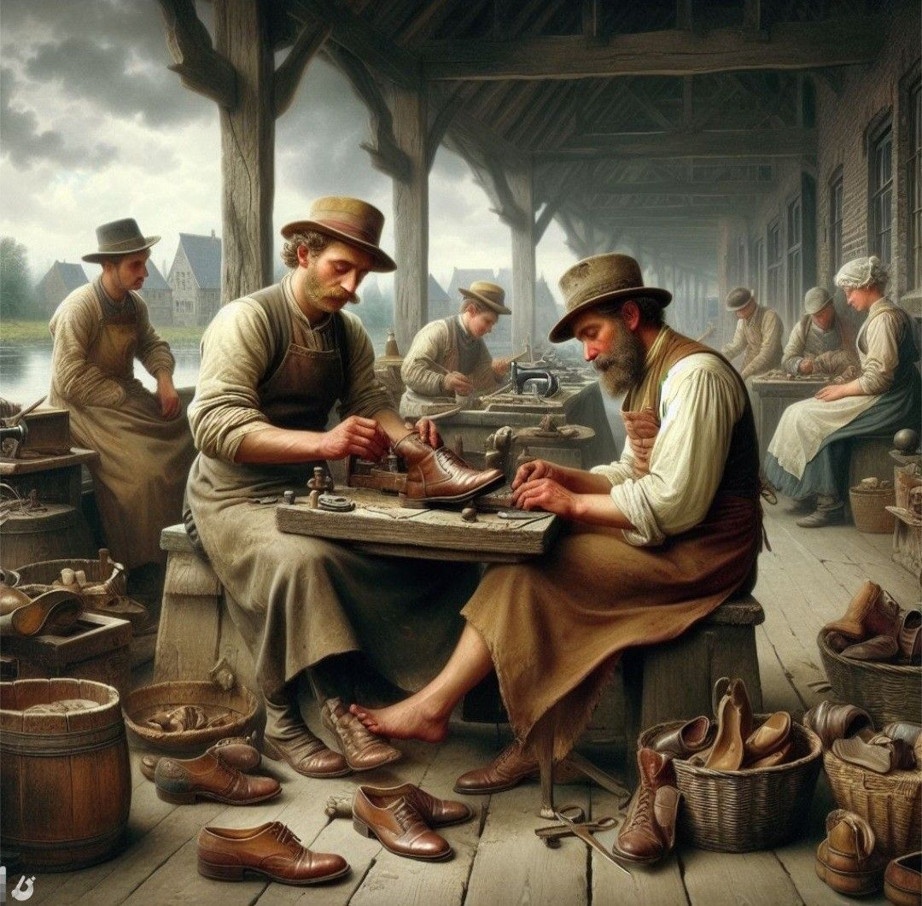

For this website proposal, the target organization would be Tailoring and shoe repair, which falls under the Retail store.

* **Name: [ Organization name]**

Tailoring and shoe repair

* **Provide a brief description of the Organisation.**

A tailoring and shoe repair organization specializes in the maintenance, customization, and restoration of garments and footwear

* **Mission and Vision statement**

Mission Statement

We deliver expert tailoring and shoe repair that blend comfort, style, and sustainability—focused on quality craftsmanship, customer satisfaction, and prolonging the life of your garments and footwear.

Vision Statement

Our vision is to be the go-to local expert in tailoring and shoe repair, promoting sustainable choices, timeless style, and a tradition of quality over replacement.

* **Target Audience**

The football players and executives

School kids and professionals and fashionistas

* **Website Goals and Objectives**

Clearly display services like alterations and shoe fixes with pictures and details.

Share customer reviews and show your skills and experience.

Explain how repairing clothes and shoes helps the environment.

Use discounts, loyalty rewards, and updates to encourage repeat visits.

**Website Objectives**

Design a mobile-friendly site with simple navigation and clear buttons like “Book Now” or “Get a Quote.”

Add a gallery with before-and-after photos of tailoring and shoe repairs.

Include location, hours, contact details, and pricing

* **Current Website Analysis (If Applicable):**

Strengths of Existing Websites

Services are listed clearly so visitors immediately see what’s offered.

Local keywords boost visibility in nearby searches.

Before-and-after photos highlight quality of work

Customer reviews add credibility and trust.

Weaknesses of Existing Websites

* Outdated, cluttered, and slow design that isn’t mobile-friendly.
* no blog posts and guides, missing SEO and engagement.
* No online store or payment options, limiting sales.
* Bland, inconsistent branding that doesn’t stand out.

**Areas for Improvement**

Website Design & User Experience

* Use a clean, responsive layout for all devices
* Streamline navigation with clear menus and direct booking/contact links
* •Speed up pages by optimizing images and using lightweight design element

Branding & Visual Identity

consistent logo, color palette, and tone for a professional look

High-quality photos of completed work and happy clients to build trust

Spotlight what makes you unique—eco-friendly methods, fast turnaround, or years of expertise

**Proposed website features and functionality**

Homepage

Purpose: Make a strong first impression and highlight your services.

Features:

• Bold hero banner with a catchy tagline

• Direct links to services, booking, and contact

• Review carousel showcasing testimonials

About Us

Purpose: Earn trust by sharing your journey.

Features:

• Mission and vision statements

• Staff or workshop photos

• Awards, certifications, years of experience

**Technical requirements**

Languages and Frameworks

HTML5 is the foundation of my site. It structures the content—like headings, paragraphs, images, and forms.

**Budget:**

DIY/template build: R0–R1 500

• Premium WordPress theme: R1 500–R4 000

• Freelancer or agency: R3 000–R8 000

**4. Maintenance Costs**

Includes updates, backups, security checks, and content changes:

• DIY maintenance: Free (if done by student or business owner)

• Professional maintenance: R300 – R900/month for small business sites

• Annual maintenance (basic): ± R3,600 – R10,800

**Reference:**

Afrihost, 2025. Web hosting plans. [online]< <https://www.afrihost.com/web-hosting>> [Accessed 15 August 2025].

Bootstrap, 2025. Introduction. [online]< <https://getbootstrap.com/docs/5.5/getting-started/introduction/> >[Accessed 15 August 2025].

Bluehost, 2025. Shared hosting pricing. [online]< <https://www.bluehost.com/hosting/shared> >[Accessed 15 August 2025].

Hostinger, 2025. Web hosting. [online] <[https://wwwhostinger.co.za/web-hosting>](https://www.hostinger.co.za/web-hosting) [Accessed 15 August 2025].

PHP.net, 2025. What is PHP? [online]<<https://www.php.net/manual/en/intro-whatis.php> >[Accessed 15 August 2025].

WordPress.org, 2025. About WordPress. [online]< <https://wordpress.org/about/> >Accessed 15 August 2025.